Estd – 2006 “Knowledge is Power”
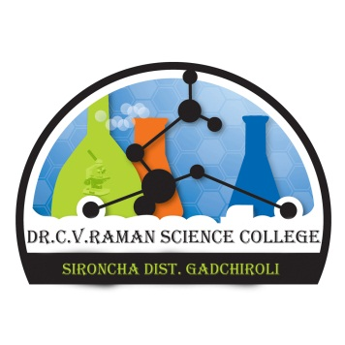
Run by, Van Vaibhav Shikshan Mandal, Aheri
Regd. No. MH - 63/84
Dr.C.V.RAMAN SCIENCE COLLEGE, SIRONCHA
Tah. Sironcha Dist. Gadchiroli
(Affiliated to Gondwana University, Gadchiroli)

Phone No. 07131-233203 College Code - 033 Off. Principal
Mob. No. 9405323986 Dr. S. H. Shende
Website :- www.cvrsironcha.com Ph.D.(Bot).
E-mail Id :- cvraman.src@gmail.com
================================================================================
Ref. No.- DCVRSC/ 1480(A) /2018 Date : 12/01/2018

Report on the work shop on Intellectual Property Rihgts[IPR]

IQAC of Dr.C.V.Raman Science College Sironcha.Dist- Gadchiroli has conducted workshop on Intellectual property Rights[IPR] On 12/01/2018 .The program was inaugurated by Dr.S.H.Shende officiating principal of the college by performing Saraswathi pooja by lighting lamp. Prof Ranjit .N. Gagapurapu did the anchoring. It was guided by Adv. Shivaji Ramanna.Totawar and Dr.Yogiraj.S.Urkude HOD Of political science Bhagvantarao Arts College, Sironcha Dist- Gadchiroli it was mainly focused on copy right and patents.
Faculty members Prof.S..R.Shaikh, K.M.Patil, and Non-Teaching members Shri.A.Y.Kalane, Shri.R.S.Puppalwar, Shri.K.D.Ondare, Shri.Kr.Rachhawar, Shri.T.A.Shaikh, Shri.R.B.Ragam, Shri.SB.Sainwar and students of the college took active involvement in the program.
The above program was found to be very useful.
